* Smoke Testing has a goal to verify “stability” whereas Sanity Testing has a goal to verify “rationality”.
* Smoke Testing is done by both developers or testers whereas Sanity Testing is done by testers.
* Smoke Testing verifies the critical functionalities of the system whereas Sanity Testing verifies the new functionality like bug fixes.
* Smoke testing is a subset of acceptance testing whereas Sanity testing is a subset of Regression Testing.
* Smoke testing is documented or scripted whereas Sanity testing isn’t.
* Smoke testing verifies the entire system from end to end whereas Sanity Testing verifies only a particular component.

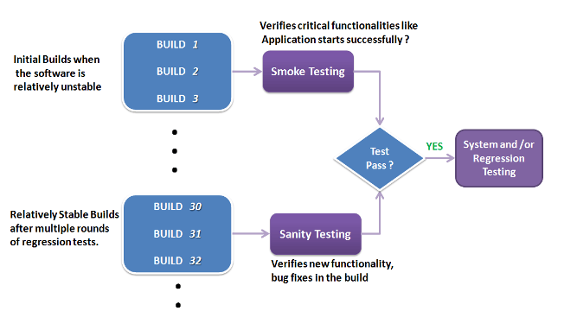

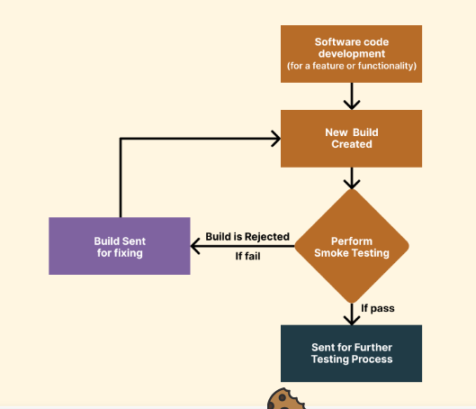

Build suspension:🡪

If smoke testing failed testing team reject software build and request

Developer to fix the build…